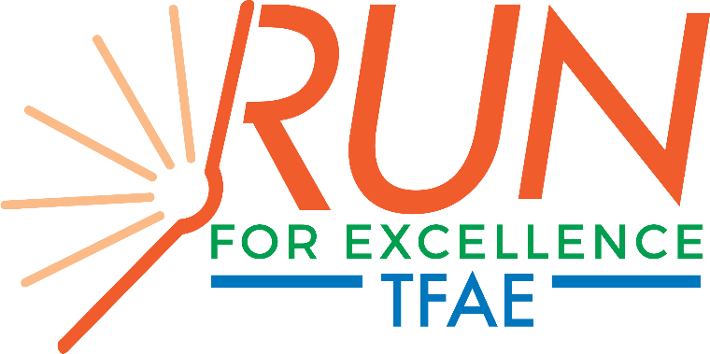
Saturday, May 11 Downtown Houma

TFAE Run for Excellence Food Partners:
THANK YOU! It is only with your support that we can host an event of this magnitude for all to enjoy!

Here are some pointers to make your day run as smooth as possible!
- All food partners and their workers/volunteers must have on a Food Partner Wristband!
- Please note that the wristbands you are given are for adults 21 years of age and older. If you need to swap for wristbands for those under 21 years of age, please let us know
- Bring your picture ID
- Please do NOT bring glass containers
- Please keep your area clean
- TFAE will have up to 2 tables and chairs for your area
- If you requested ice, bring an ice chest
- If you requested electricity, bring extension cords
- Please be sure your area has a fire extinguisher
- If you are competing in the Best of the Fest Competition
  - Your food sign will have a star on it to signify that you are participating
  - You will receive a small container to collect votes/tickets
  - Encourage guests to vote for you
  - Containers will be collected at 9 p.m.
  - In an effort to be fair, do NOT combine your tickets with any other food partners
- You can begin set up at 9 a.m. on Saturday, May 11th
- Please be ready to serve at 6 p.m. Please do not serve anyone before 6 p.m.
- If you have more than 5 people in your booth, they are responsible for paying the volunteer fee of $15. You can purchase in the TFAE office the week before the event – call or email contact below to arrange.
- If you want to participate in the 5K race, please fill out separate 5k form and return to TFAE office or by email no later than noon April 19. (form can be found on website) runforexcellence.com
TFAE cannot thank you enough for participating in this event. For over 20 years, we have created a reputation of being one of the most attended and loved festivals in Houma. It is with your help and delicious dishes that we continue that tradition! We can’t do it without you! Please contact us with any questions contact Ashlee ashlee@tfae.org or 985.381.7390.

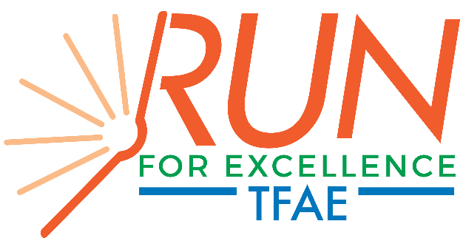FOOD PARTNER AGREEMENT
. F ood Partner Receives:
*Company or Individual name highlighted on media and signage at event-deadline Friday, April 19 2024.

*Company name in all media outlets--deadline is April 19, 2024.
- 5 complimentary event wristbands and t-shirts.
Any additional passes will be subject to a volunteer fee of $15

Please remember that this is a family friendly event and our main fundraiser ©

COOKS AND HELPERS Will HAVE TO CHECK IN AND HAVE ON THEIR PRE-ISSUED WRISTBANDS!
..Food Partner Donates.: 600-4oz. servings

Food Partner and Item______________________________________________________________
(Name ta appear in print) (Name to appear in print)

Circle One……………..Company provides volunteers to serve food OR TFAE provides volunteers to serve food

NAME YOUR VOLUNTEERS AND SHIRT SIZES: 1.___________________________________
2._____________________________3.___________________________________4.______________________________
5.________________________________________________________

Electrical Requirements (approx. amps.)=- ­
(You must provide your own extension cords.)
List what you will need from the following: bowls, boats, forks, and/or spoons

Will you need ice? YES NO You will need to provide your own ice chest(s).
If your food item will require you to bring a trailer, please detail size below.
_________________________________________________________
Will you provide your own tent? Yes No Size tent?

Do you want to participate in the BEST OF THE FEST! food/beverage competition? Yes or NO

I have read and agree to the above sponsorship contract with TFAE and will honor this agreement.

______________________________________________________
Food Partner (Contact Person) Please Print

Phone# ,­
·cell#

'
Please complete, sign, scan, and email the completed form no later than April l9
ashlee@tfae.org

